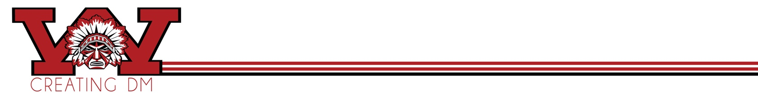
Name______________________________ Points_________/70

Cereal Box
Your objective for this project is to invent a new brand of breakfast cereal. Think about your target audience and what your theme is then come up with a name for the cereal and design an effective logo. You must draw the focus of this using Illustrator. A design for sugary cereal targeted towards children should be different than organic oats for adults, right? As always, I would suggest using your sketch pad to sketch out ideas….

Front Panel: (20)
- Company Logo
- Name of the cereal Logo
- Graphic and photos (original)
- Size, Calories and/or Highlights of Nutrition

Back Panel: (10)
- Puzzles, Games, Facts, etc, maybe more QR Code

Left Side Panel: (8)
• Company Logo or Cereal Logo
• Nutritional Facts

Right Side Panel: (8)
• Company Logo
• Ingredients
• Website address

Top Flap: (5)
- Company Logo or Cereal Logo minimum
- Area for Expiration Date
- Recycling Information

Bottom Flap (4)
- UPC Code
- Company Logo or Cereal Logo minimum

Layout of all sides (5)
Cut out and put together, creativity, time spent (10)

You will be printing your design and cutting out the package, so keep your bleeds and margins in mind.

Before you begin… Lay this out in your sketch book…Come up with a name, logo

